**Coupling induction-depression by a decoupled magnon**

**Fizaan Khan, Sachin Verma, Biswanath Bhoiand Rajeev Singha**

1Nano-Magnetism and Quantum Technology Lab, Department of Physics, Indian Institute of Technology (Banaras Hindu University) Varanasi, Uttar Pradesh- 221005, India

We investigate photon-mediated magnon–magnon coupling (MMC) between spatially separated Yttrium Iron Garnet (YIG) and Permalloy (Py) thin films integrated into a planar hexagonal ring resonator (HRR). Using CST Microwave Studio, we perform full-wave simulations that reveal clear signatures of MMC even in the absence of direct dipolar interaction between the magnetic films. Notably, the coupling strength between the HRR and the Py film increases with the thickness of the YIG film, despite a fixed Py film thickness—suggesting the presence of an indirect interaction channel mediated by HRR’s photons. To support these findings, we present a theoretical model that accurately reproduces the simulated transmission spectra (S21) and reveals a nontrivial interdependence between the individual coupling strengths of YIG and Py to the HRR. These results underscore the importance of indirect interactions and potential crosstalk pathways in designing hybrid magnonic systems and scalable quantum architectures, while demonstrating the feasibility of cost-effective, planar configurations for experimental implementation. These insights are valuable for advancing low-loss, coherent information transfer in hybrid quantum devices.

***Index Terms*:** Strontium Hexaferrite, Micromagnetic Simulation, Sub-Terahertz application.

aCorresponding author E-mail: [rajeevs.phy@itbhu.ac.in](mailto:rajeevs.phy@itbhu.ac.in)

**Introduction**

The advancement of hybrid quantum systems that integrate magnonic and photonic components has emerged as a critical frontier in the pursuit of scalable quantum information processing and next-generation microwave technologies [1, 2]. In such systems, magnons—the quanta of spin waves—interact coherently with microwave photons, enabling unique functionalities such as tunable coupling [----], non-reciprocity [----], and quantum transduction [---]. As these device architectures continue to scale down toward nanoscale dimensions [3, 4], the complexity of electromagnetic interactions increases, particularly due to the emergence of indirect or unintended couplings between spatially separated components. These couplings are often mediated by shared photonic modes or circuit environments and can lead to both detrimental crosstalk and potentially useful long-range interactions [5, 6]. Understanding and controlling these mediated interactions is therefore essential for the design of robust, coherent, and scalable hybrid quantum devices.

Material choice plays a crucial role in determining coherence, coupling strength, and scalability in hybrid quantum systems. Yttrium Iron Garnet (YIG), with its low damping and long spin-wave coherence, has emerged as leading candidate for magnonic quantum circuits [1, 2, 7, 8]. It enables strong and ultrastrong photon-magnon coupling (PMC) in planar superconducting resonators, with recent studies showing coupling-to-frequency ratios > 0.2 [8]. Similarly, Likewise, lithographically patterned organic ferrimagnets have demonstrated cooperativity values exceeding 103 at cryogenic temperatures, paving the way for their integration with superconducting qubit platforms and enabling circuit quantum electrodynamics (cQED) functionalities within magnon-based architectures [5]. These advances highlight the growing maturity of hybrid PMC systems and underscore the need for deeper exploration into their nontrivial coupling dynamics—particularly those arising from indirect, photon-mediated interactions between spatially separated magnetic elements

While the Dicke model provides a foundational framework for describing magnon–photon coupling in single-mode systems, it falls short in capturing the complex dynamics of multimode or heterogeneous magnetic systems [9, 10]. Unresolved theoretical and experimental challenges persist—particularly in understanding mediated coupling, the dependence of interaction strength on spin density and spatial configuration, and the role of decoherence in nonlocal systems. Notably, Hyde et al. observed that certain indirectly coupled modes can surpass their directly coupled counterparts in transmission amplitude [11], highlighting the need to reassess the conventional assumptions surrounding circuit isolation and crosstalk. As previous work suggests that cavity photons can act as effective mediators for long-distance coupling in hybrid architectures [12], we investigate this phenomenon using a hexagonal ring resonator (HRR) as the coupling platform. The HRR provides a planar, symmetric platform well-suited for probing such mediated interactions and exploring their impact on the coherent dynamics of spatially separated magnetic elements.

This study demonstrates that photon-mediated interactions between a YIG film and a spatially separated Permalloy (NiFe) film, integrated via a hexagonal ring resonator (HRR), can give rise to measurable MMC, even in the absence of significant direct dipolar overlap. The observed coupling arises from the nonlocal electromagnetic modes of the HRR, which effectively bridge the two magnetic films. Importantly, the coupling strength is found to depend sensitively on the spatial configuration and electromagnetic response of circuit elements that are otherwise considered independent. Notably, this mediated interaction persists even when the individual PMC lie well below the ultrastrong coupling threshold, emphasizing the relevance of indirect pathways in the overall system dynamics. These results suggest that conventional approaches to suppressing crosstalk in magnonic integrated circuits may need to be revised to account for long-range electromagnetic interactions. To model the system, we employ input–output theory [15, 16] instead of the conventional Schrieffer–Wolff transformation [13, 14], allowing us to extract the transmission parameter 𝑆21 and directly compare theoretical predictions with simulation data. The design is intentionally simple and scalable: implemented on a millimeter scale, operable at room temperature. Despite its simplicity, the platform captures essential features of cavity quantum electrodynamics (cQED) and offers a promising testbed for investigating mediated coupling in accessible, low-cost quantum device architectures.

**Design and Numerical Modeling of the Hybrid Photon-Magnon System**

In designing hybrid systems, it is essential to account for the various forms of hybridization and their collective influence on the system’s dynamics. To explore these effects, we investigate magnonic interactions in a configuration specifically chosen to minimize direct dipolar coupling, allowing us to isolate and analyze interaction pathways mediated indirectly through a common bosonic mode i.e. photons. The simulated hybrid system features HRR placed in close proximity to a microstrip line and integrated with two magnetic films—YIG and Py—mounted on opposite arms of the HRR within a planar geometry, as illustrated in Figure 1. When a microwave current propagates along the x-axis through the feeding line, it produces a transverse microwave magnetic field that excites the HRR (depicted in dark yellow), which functions as a parallel LC circuit exhibiting quasi-static resonance. This resonant field, in turn, interacts with the magnetic films YIG (green) and Py (silver) integrated into the HRR inducing their respective magnon modes and enabling the probing of respective photon–magnon coupling dynamics. The full-wave electromagnetic solver CST Microwave Studio was employed to simulate individual hybrid configurations HRR–Py, HRR–YIG as well as the combined hybrid system HRR–YIG–Py. The simulations employed standard material parameters for the magnetic films: for YIG (and similarly for Py, unless otherwise noted), the gyromagnetic ratio was set to γ = 1.76 × 10⁷ rad/Oe·s (1.82 × 10⁷ rad/Oe·s), the saturation magnetization was M = 1720 G (10900 G), the Gilbert damping constant was α = 1.4 × 10⁻⁴ (1× 10⁻2), and the magnetic anisotropy was assumed to be negligible. The dimensions of the HRR, the microstrip line, the YIG and Py films are indicated in the captions of Fig. 1 (for further details also see Ref. _ _ _)

To investigate photon-mediated magnon–magnon coupling, we obtained the transmission spectra |S₂₁| as a function of microwave frequency under a static external magnetic field H applied along the y-axis at room temperature. Figures 2(a), (b), and (c) show the |S₂₁| power spectra on the *f*–*H* plane for the hybrid systems HRR–Py, HRR–YIG, and HRR–YIG–Py, respectively. In this setup, the photon mode associated with the HRR behaves as a fixed-frequency resonance determined by the geometry of the LC structure. In contrast, the magnon modes in YIG and Py follow the Kittel relation [17], resulting in a frequency that shifts with the applied magnetic field. The strength of photon-magnon coupling is inferred from the degree of avoided level crossing an established indicator of coherent energy exchange, particularly relevant in applications such as quantum sensing and quantum memory buses.

As shown in Fig. 2(a), the Py–HRR system exhibits only weak coupling, which is expected due to the metallic nature of Py that introduces higher damping and noise. In contrast, Fig. 2(b) demonstrates that the YIG–HRR system exhibits strong coupling, attributable to YIG’s low damping and high spin-wave coherence. Interestingly, in the combined system (Fig. 2(c)), the Py mode displays a markedly enhanced coupling signature compared to its isolated behavior, while the YIG coupling appears slightly diminished. This suggests a redistribution of interaction strength facilitated by the HRR's photon mode, emphasizing the role of photon mediation in enabling effective magnon–magnon interactions between spatially separated magnetic elements.

**Theoretical Formalism for Photon Mediated Magnon-Magnon Coupling**

To gain deeper insight into the numerically observed photon-mediated magnon–magnon coupling and to quantitatively estimate the corresponding interaction strength, we developed a microscopic model based on quantum mechanical principles. This approach provides a robust framework for describing the coupled dynamics of the system, effectively capturing both direct and indirect interactions, and is readily extended to systems involving multiple coupled quantum harmonic oscillators.

The theory we propose in this work is a generalized version that may be extended to any number of quantum harmonic oscillators. We are specifically interested in a triple oscillator system: a cavity photon coupled to two thin magnonic films. A driving field is provided through a microstrip line (denoted in equation (3) as “msl”), which is assigned the annihilation (creation) operator

). The subscript *k* denotes a frequency-dependent operator that supports all frequencies, implying an integral over all real *k*.

For each of the oscillators, we define yet again the annihilation (creation) operator as ˆ*bj* (ˆ*b*†*j*), where *j* takes on one of the symbols *r* (denoting the photonic resonator), 1 or 2 (denoting the magnonic resonators).

We begin with the definition of the system’s Hamiltonian *H*ˆ = *H*ˆnon-int + *H*ˆint+*H*ˆmsl, denoting the non-interacting, interacting, and microstrip line hamiltonians respectively, where each expands to

(1)

 + h.c. (2)

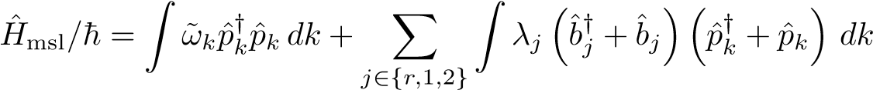 (3)

The quantity ˜*ωj* = *ωj* + *iαj* refers to the natural frequency of the oscillator and includes its intrinsic damping constant *αj*.

The microstrip line requires a continuous integral over all supported input frequencies. Equation (3) represents the driving field Hamiltonian of the microstrip line. In contrast, equation (2) includes the coupling of all the resonators amongst themselves and a term that captures the coupling of each of the resonators with the microstrip line.

Note a term of direct dipolar coupling between ˆ*b*1 and ˆ*b*2: *g*3. As shall be seen, however, its contribution to the *S*21 parameter is negligible.

The equations of motion for the three oscillators are readily calculated by a standard procedure[18, 16].

If we set *γi* = 2*πλ*2*i*, the *S*21 parameter for such a system, given by *S*21 =

*p*ˆout*/p*ˆin − 1 is[19]

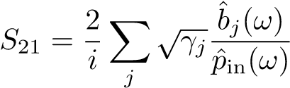 (4)

which, rewritten in the form of a matrix

*S*21 = *BT*M−1*B* (5)

where

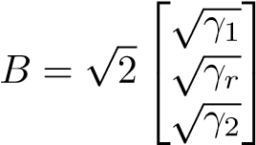 *,*

and , where *I* is the 3×3 identity matrix and *H*ˆcoupling is the effective coupling Hamiltonian[19], from the equations of motion for the mode operators, given by

*H*ˆcoupling 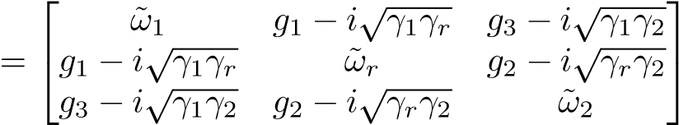 (6)

The terms on the diagonal include intrinsic and extrinsic damping terms, in the form ˜*ωj* = *ωj* − *i*(*αj* + *γj*)[19], and *ωj* represents natural frequency of oscillator *j*. Since we are ignoring terms of direct magnon coupling, there are no coupling constants on the edges of the off-diagonal.

The measurable quantity is the coupling strength among resonators; at the coupling centers, this denotes the extent to which the crossing of the peaks in the S21 spectrum is avoided and may be measured by corresponding peak separation. The coupling is a result of classical phenomena [12]. Past analyses have shown that it depends broadly on intrinsic material parameters such as αj[20]. While the model predicts related effects for large αj, they occur in discrete steps, in contrast with what we have (thus far) observed.

**Discussions**

Seen in Fig 3 are the S21 spectra observed (top) and predicted by the theory (bottom), respectively, for various thicknesses of the YIG ferrimagnet. The details of the setup are discussed in detail in section 5. The parameters g1, g2 and g3 were fitted such that the overlay of the white curves (the peak positions are the eigenvalues of the coupling Hamiltonian (6) at each magnetic field strength H) on the observation was the closest possible, and then the full spectrum was plotted separately. This best fits the relevant model parameters, which agree well with observations.

Going from left to right in Fig 3, the thickness of the YIG film is increasing. Predictably, the coupling of this magnon with the HRR increases with this thickness. Interestingly, we note that the Permalloy film’s coupling with the resonator also depends on the thickness of the other film.

When the coupling strength of the YIG film in the absence of Permalloy is plotted against its thickness (Fig 4a), it follows a linear trend. On the introduction of the Permalloy film (Fig 4b), the slope remains the same (at about 2), but the line shifts downward. The Permalloy seems to return an unchanging influence on the coupling strength of the YIG mode. Note, however, that g3 is negligibly small due to our selection of a low overlap configuration. Any observable interaction between the two magnons in this configuration is mediated through the resonator photon.

This sensitivity to an external parameter of the Permalloy film seems to suggest an indirect dependence on the YIG film that is not captured within the scope of the quantum model. There is perhaps a transfer of energy or an overlap of the magnetic fields.

It seems to us most appropriate at this point to claim that the quantity g1 depends on g2 linearly, as is seen in Fig 4c. It inspires confidence to see that g1(0) is non-zero and, in fact, the coupling constant of the Permalloy film in the absence of YIG.

**Conclusion**

In conclusion, this work bridges the gap between fundamental magnonics and practical device engineering. Elucidating photon-mediated coupling in accessible macroscopic systems provides a roadmap for low-cost classical applications and future quantum technologies requiring precise control over indirect spinphoton interactions. The results underscore the necessity of revisiting cQED models to account for all co-dependent phenomena.

.

**Acknowledgments**

The work was supported by the Council of Science & Technology, Uttar Pradesh (CSTUP), (Project Id: 2470, CST, U.P. sanction No: CST/D-1520). B. Bhoi acknowledges support by the Science and Engineering Research Board (SERB) India- SRG/2023/001355. R. Singh acknowledges support from the Council of Science & Technology, Uttar Pradesh (CSTUP), (Project Id: 4482). S. Verma acknowledges Ministry of Education, Government of India for the Prime Minister's Research Fellowship (PMRF ID-1102628).

**Statements & Declarations**

**Funding:** The authors declare grants or other support were received during the preparation of this manuscript.

**Competing Interests:** The authors declare that they have no competing interests.

**Author Contributions:** All authors contributed to the study's conception and design. R.S and B.B. led the work and wrote the manuscript with F. Khan. The other co-authors read, commented, and approved the final manuscript.

**Data Availability**

The data that support the findings of this study are available within the article.

**References:**

**FIGURE CAPTIONS**

**Fig. 1.** The experimental setup includes the two magnonic films placed at opposing sides of a copper hexagon (the photonic resonator). The ports featured are plugged into a vector network analyzer to both excite the microstrip line and also measure the transmission spectrum while a magnetic field is applied along the y-direction pictured here.

**Fig. 2.** A comparison of the magnonic coupling strengths of the (a) Permalloy, (b) YIG, and (c) both in an indirectly coupled configuration.

**Fig. 3.** A cartoon of the model developed for this system. The spheres are bosonic oscillators with creation (annihilation) operator ˆ*b*†*j*(ˆ*bj*). *αj* and *λj* denote intrinsic and extrinsic damping, coupling the oscillators to the traveling photon mode. The constants *g*1 and *g*2 denote the coupling of the magnonic cavities to the photonic cavity.

**Fig. 4.** Observed (top row) and calculated (bottom row) *S*21 spectra of the system for corresponding thicknesses of YIG. The Permalloy crossing is also seen to widen with a change in YIG thickness.

**Fig. 5.** The blue crosses in (a) and (b) represent the coupling strengths of the YIG film to the HRR. The coupling strengths in (a) are for a system that does not include a Permalloy film. Upon introduction of the Permalloy in (b), the coupling strengths of the YIG have decreased by a fixed amount. The red dots in (b) mark the coupling strengths of the Permalloy to the HRR, and the yellow triangles are *g*3, the direct coupling between YIG and Permalloy, which is small due to the low overlap configuration. In (c), we plot the relation *g*1(*g*2), which is also linear.

Fig.1

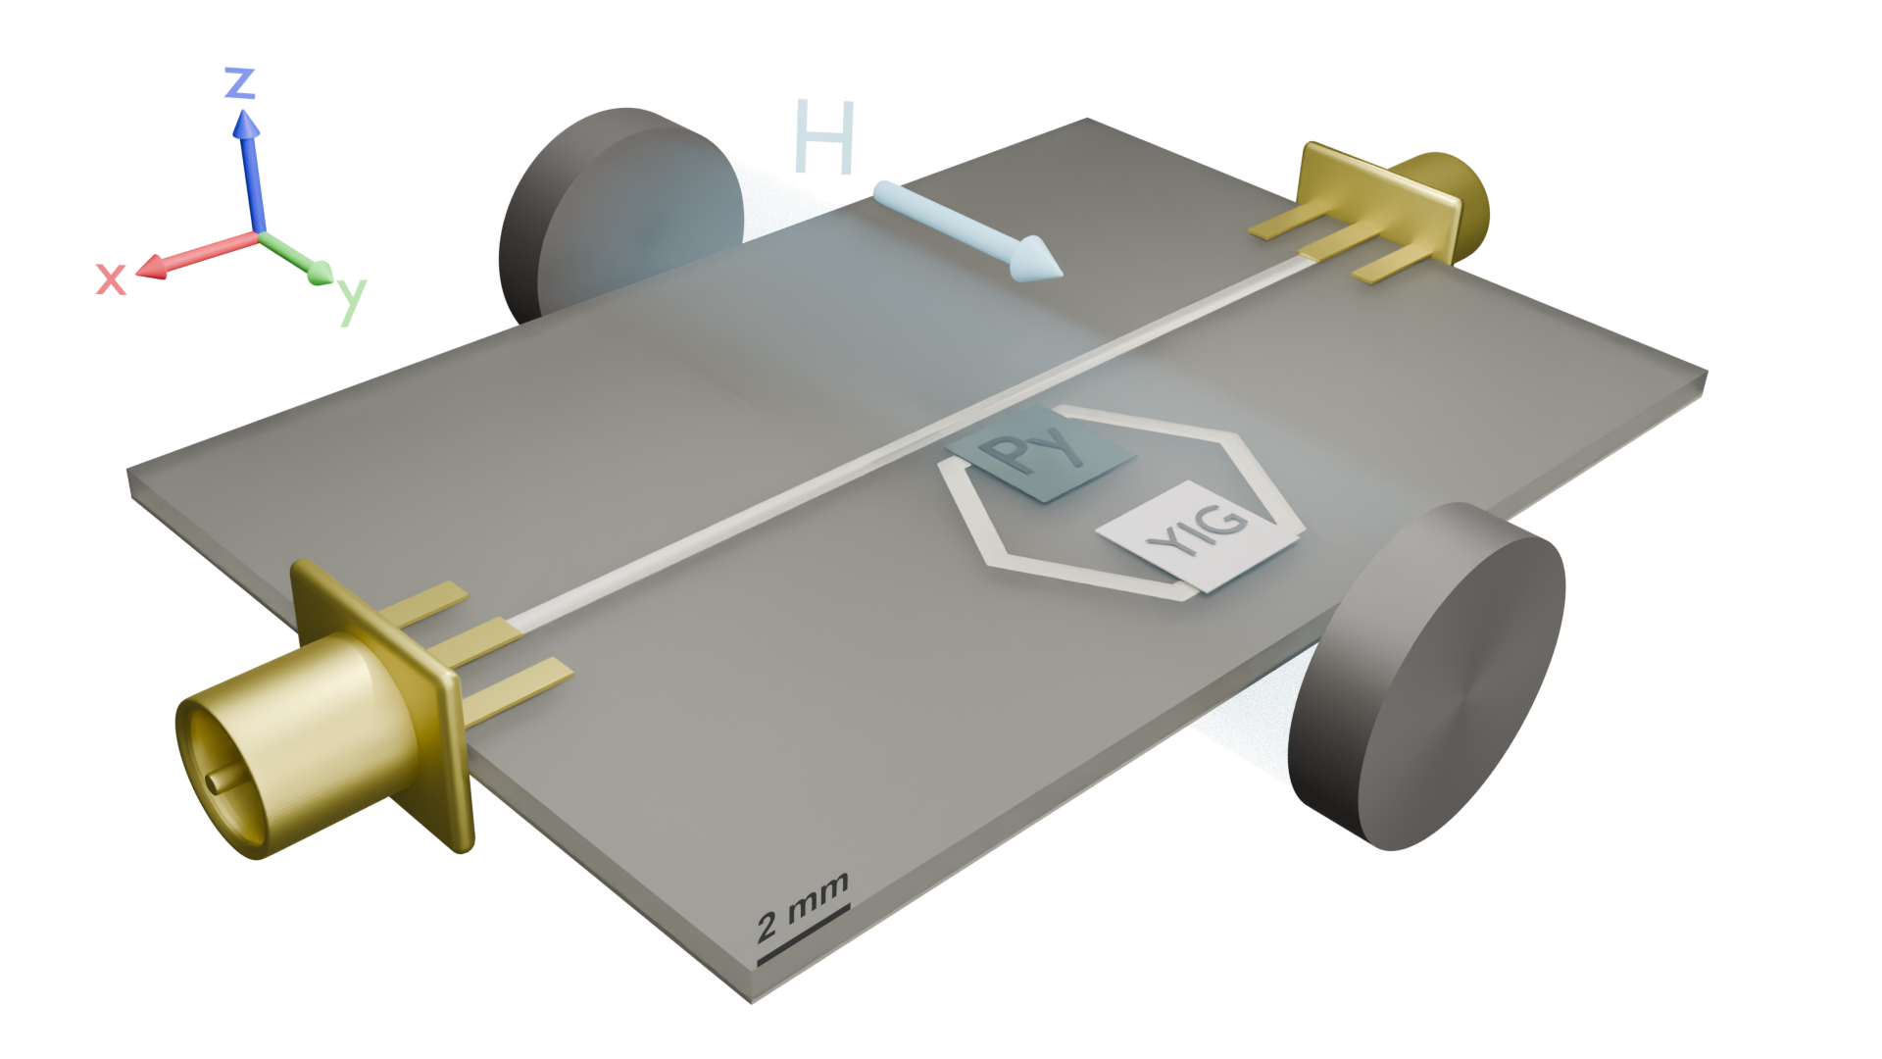

Fig.2

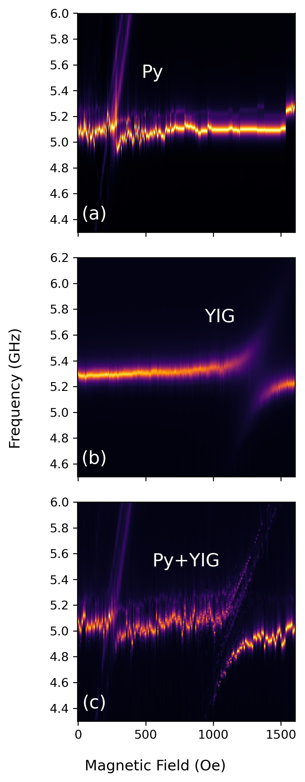

Fig. 3

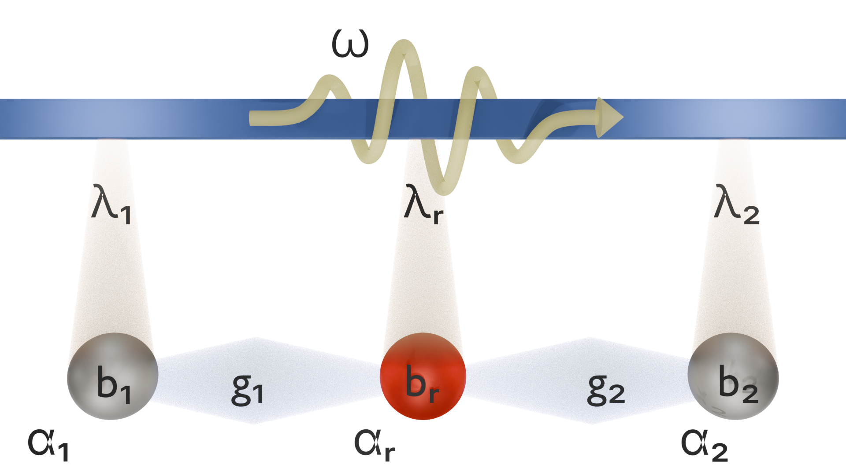

Fig. 4

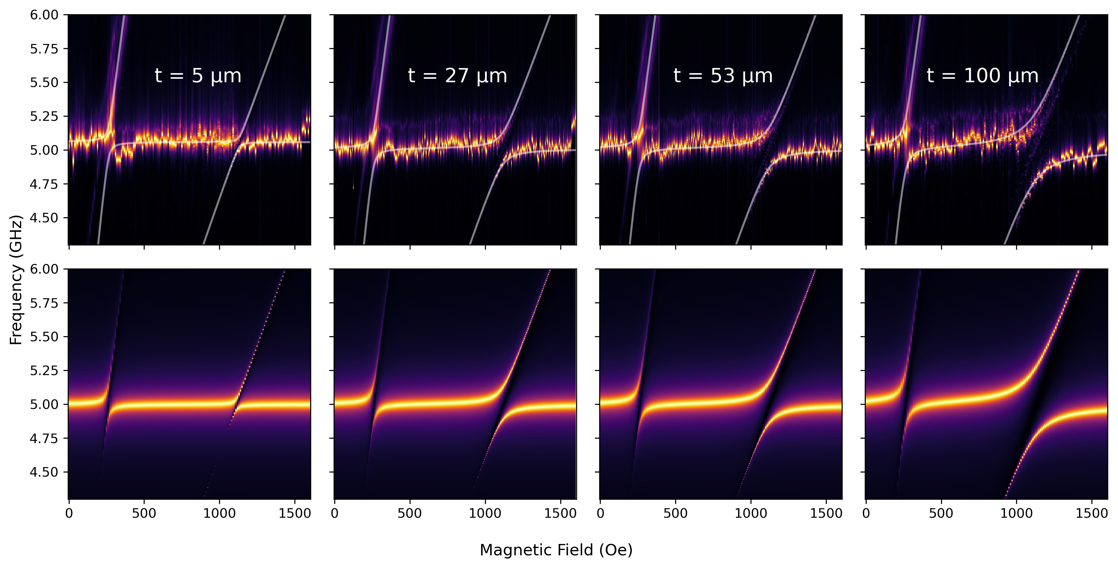

Fig. 5

